December 12, 2020

Dr. Miriam Murungi,

The Government Agreement Technical Representative (GATR), MRRH

USAID/Uganda

Kampala

Dear Madam,

**RE: MBARARA REGIONAL REFERRAL HOSPITAL REQUEST FOR REIMBUREMENT OF COMPLETED MILESTONES, UNDER FIXED AMOUNT REIMBURSEMENT (FAR) 617-IL-2020-MRRH, ATTACHMENT NO.2**

As specified in attachment 2, description of milestones/output summary and payment amounts of the Implementation Letter (617-IL-2020-MRRH) and as amended on July 8, 2020 for Mbarara Regional Referral Hospital Strengthening Project, the hospital is required to complete the identified milestones prior to requesting for payment from USAID.

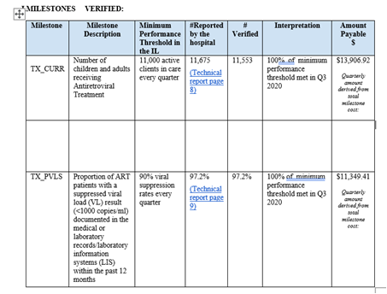

Accordingly, the hospital has achieved the milestones under TX_CURR and TX_PVLS totaling to USD 25,256.34 as reflected in the table above. Verification was carried out by SITES. MRRH hereby submits USAID SF 1034 for your review and approval of 25% of the budgeted amount for each of the milestones above.

Yours sincerely

Dr. Celestine Barigye

**Director,**

**Mbarara Regional Referral Hospital**

Cc:

1. Rena Mukasa, Chief Accountant

2. Anna Agaba, Financial Analyst

3. Shephira Natamba, Supervisor Payments

4. Kizito Muhumuza, Payment Specialist